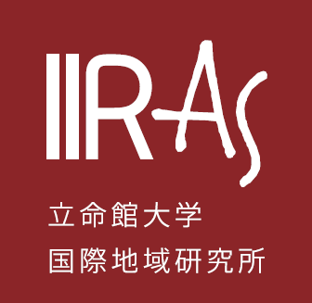
March 2026
Call for Papers

Ritsumeikan Journal of

Ritsumeikan International Affairs vol.22

The Institute of International Relations and Area Studies (IIRAS) has been leading various research projects that aim to explore the nexus between international relations theories and empirical area studies. It has put emphasis on major global issues, including peace-building, regional integration, transnational movement, and global governance, with strong attentions to the Asia-Pacific and European regions. IIRAS publishes its journal, Ritsumeikan Journal of International Relations and Area Studies, in order to disseminate research in our field and share its findings with scholars all over the world. With this Call for Papers, we strongly encourage you to submit your writings for publication.
The following are the requirements for submission:
Eligibility: applicants must meet at least one of the following requirements
- A faculty member of Ritsumeikan University
- A member of a project sponsored by IIRAS
- A graduate student at Ritsumeikan University
- A person who is requested by IIRAS to submit a manuscript

Format: articles, research notes or book reviews related to international affairs or area studies

Publication: manuscripts approved by the editorial committee will appear in the Journal

Note: unless the contributor is a professor or associate professor of Ritsumeikan University, the submitted manuscript is basically subject to peer review. Those who satisfy eligibility requirement 4 will not need to take the committee examination.

Note: All manuscripts must be attached with the application form.
Manuscript Submission Deadline (peer review) | May 29, 2026 at 11:59pm
Manuscript Submission Deadline (without peer review): | August 21, 2026 at 11:59pm
Online First Pre-Publication  (To be included in March 2027 at the time of publication of the  printed version. | October, 2026
Manuscript Submission Deadline (peer review) | November 13, 2026 at 11:59pm
Manuscript Submission Deadline (without peer review): | January 8, 2027 at 11:59pm
Print Publication | March, 2027

Language: English

Manuscript Length:
- Article: maximum of 8,000 words (including charts, graphs, endnotes and references)
- Research Note: maximum of 5,000 words (including charts, graphs, endnotes and references)
- Book Review: maximum of 2,000 words (including endnotes and references)

Additional Notes:

- We welcome submissions from research projects sponsored by IIRAS.
- An abstract of no more than 150 words and five keywords should appear on the first page of each manuscript.
- The Journal will be published both in paper and online with PDF format.

Please make sure that manuscripts are proofread and follow writing guidelines as specified by the Journal prior to submission.
- Manuscripts should be submitted with Microsoft Word files.
- We do not accept book reviews or translated articles, unless they are solicited by the editorial committee.
- Please keep revisions during the proofreading stage to a minimum, limited to minor corrections such as typographical errors.
Author proofreading shall be limited to two rounds (a third round, if conducted, shall be limited to the verification of corrections only).
Should you have any questions, please contact IIRAS below:
Ritsumeikan University, Institute of International Relations and Area Studies
Email：kokuchi@st.ritsumei.ac.jp

